**Stephanie Adams Jumps-off a 25-Storey Building Clutching Her Son in an Apparent Suicide Murder Riddle.**



It was a great shock for fans to learn that Stephanie Adams jumped to her death from the balcony of Gotham Hotel in Manhattan, New York, on Friday 18 May 2018 taking with her, their 7 year old son, Vincent, in the process. Both mother and child were pronounced dead on the spot as the riddle of her despairs and the apparent murder-suicide unfolded.

According to police report, Stephanie checked into the Penthouse Suite, on the 25th floor at around 6pm local time the previous day and the incident happened at around 8.15 am on Friday 18th May. The remains of Stephanie and Vincent were found on the second floor balcony in the rear courtyard.

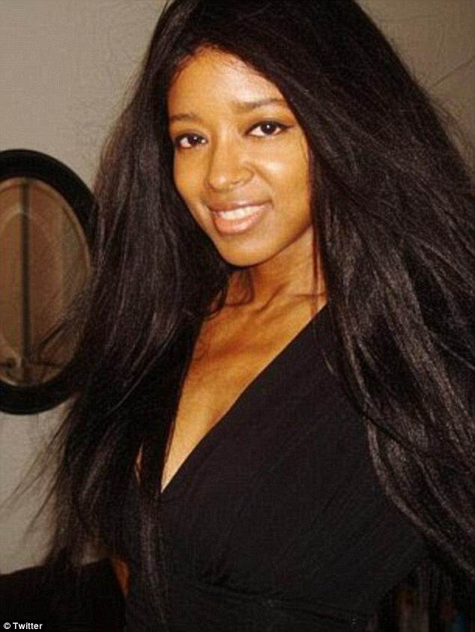

Stephanie was born July 24, 1970 in Orange, New Jersey. She was a celebrated American model and author of mixed ancestry that comprised of ancestors who were African American, Caucasian, and Cherokee respectively. She claimed that she descended directly fron two former American Presidents namely, Presidents John Adams and John Quincy Adams.

What is known at this point in time is that Stephanie Adams had been embroiled in a bitter battle with her estranged husband for the custody of their 7year old son. It is also known is that the courts recently denied her leave to take her son to Europe on a trip to meet her boyfriend. The trip was scheduled for Thursday, 17th May 2018.

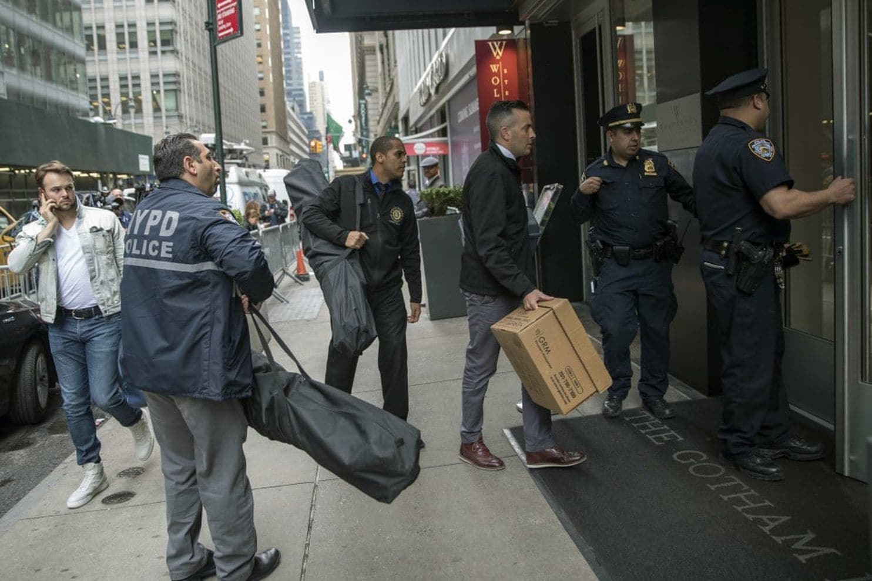

**Police Arriving at the Scene**

It is not clear, at this point whether the denial contributed to the apparent behaviour that culminated in the deaths of mother and child. However, Stephanie reportedly complained to the New York Post, a few hours before checking into the hotel ,that she was being denied a vacation with her son.

Raoul Felder, a divorce lawyer who had been a friend of Stephanie for over twenty years and who until a few months ago had been representing her in the divorce case that is still pending in court said there was a standoff in the custody case that resulted in the former husband her handing over the child to each other at the police station every time they had to hand over custody. Her estranged husband is a Manhattan chiropractor named Charles Nicolai.

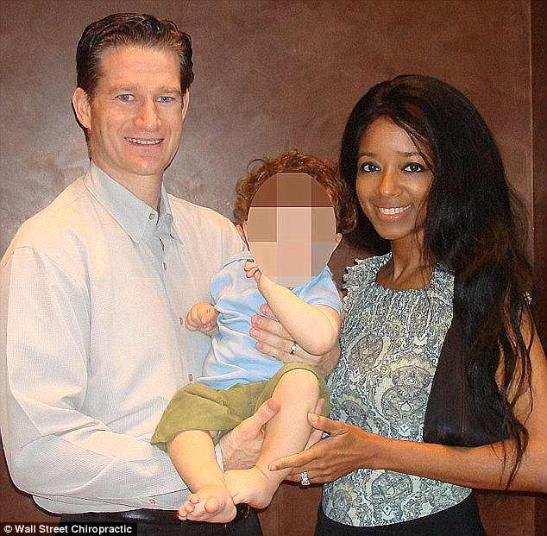

**Stepanie with Estranged Husband and Son in 2011**

According to Felder, in all the twenty years she had known her, there was no reason at any time to suspect she was depressed. Felder believes depression was not one of her problems, hence it is hard to decipher what could have gone wrong. Her estranged husband is yet to make a comment.

Stephanie Adams was “Miss November” in the centerfold of Playboy in 1992. She was featured again by Playboy in 2003. Stephanie was a top class model and she had a long term working contract with Elite Model Management.

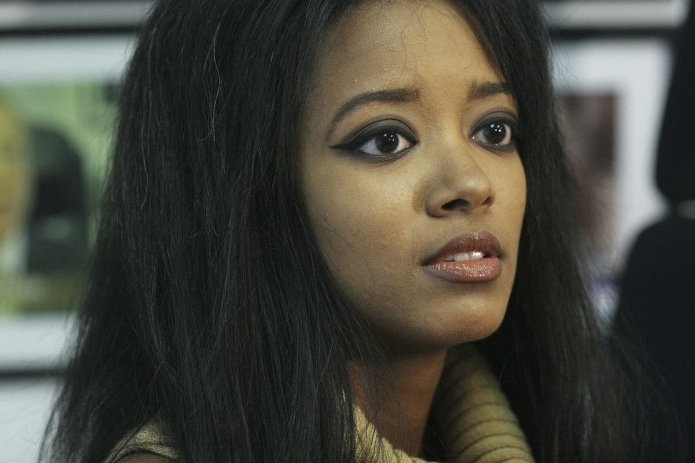

She was also a highly educated, intelligent and resourceful person. She had written over 25 self-help books, ran an online beauty products company at the time of her demise. In fact she ran the finances in her husband’s chiropractic office in Wall Street before their relationship went haywire.

She was a co-owner of the practice. Stephanie Adams was also the founder and CEO of the skin care product company Goddessy Organics. The police are still investigating and have not ruled out foul play yet.